CS 255 System Design Document Template

UML Diagrams

UML Use Case Diagram
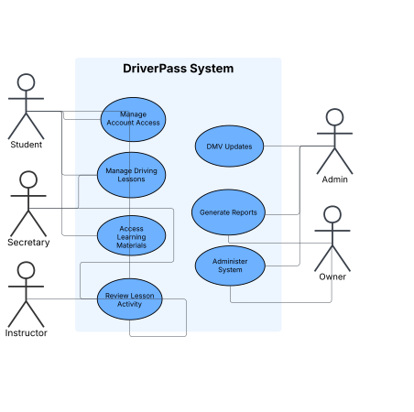

UML Activity Diagrams
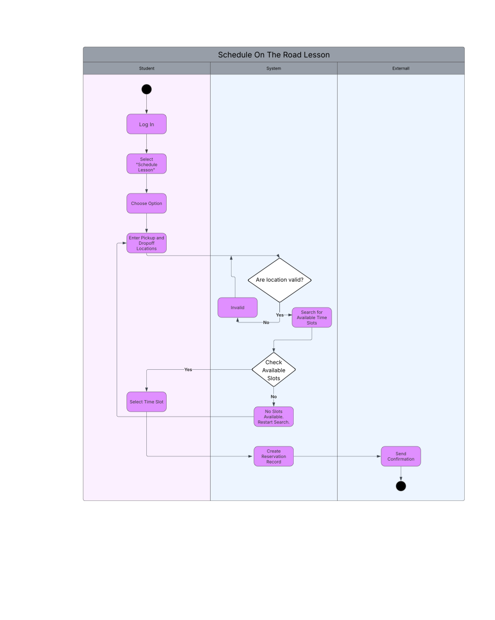

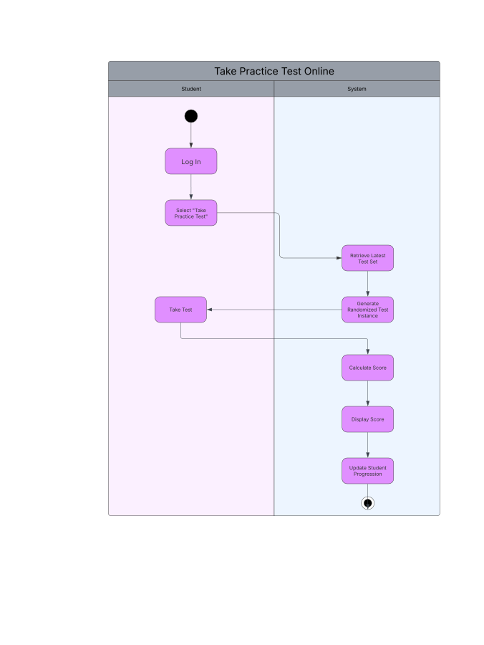

UML Sequence Diagram
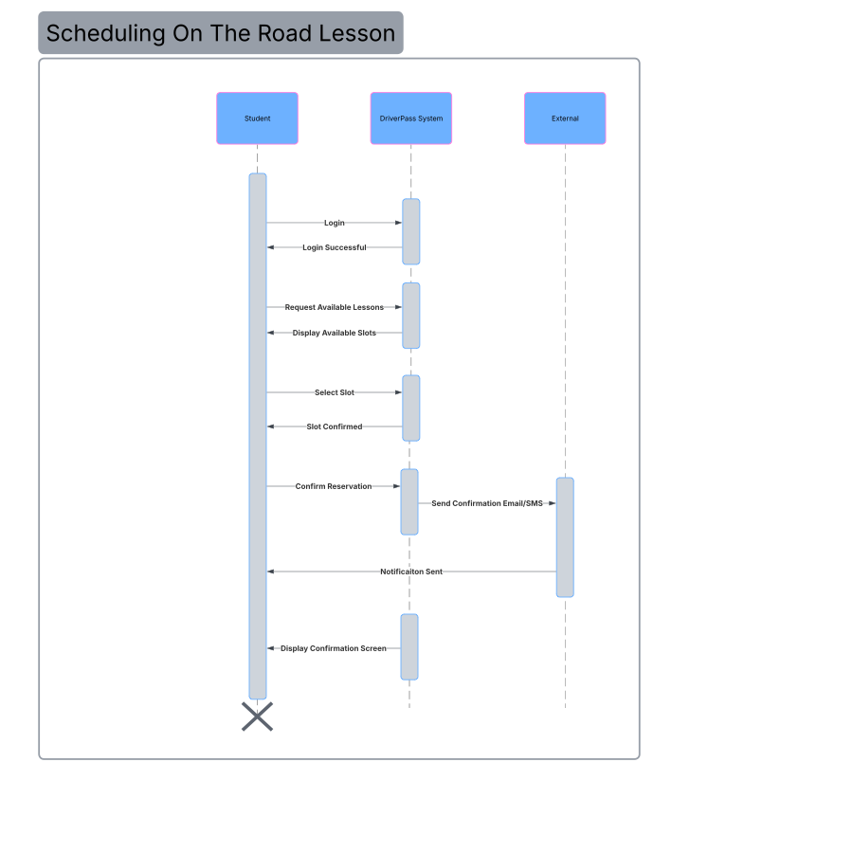

UML Class Diagram
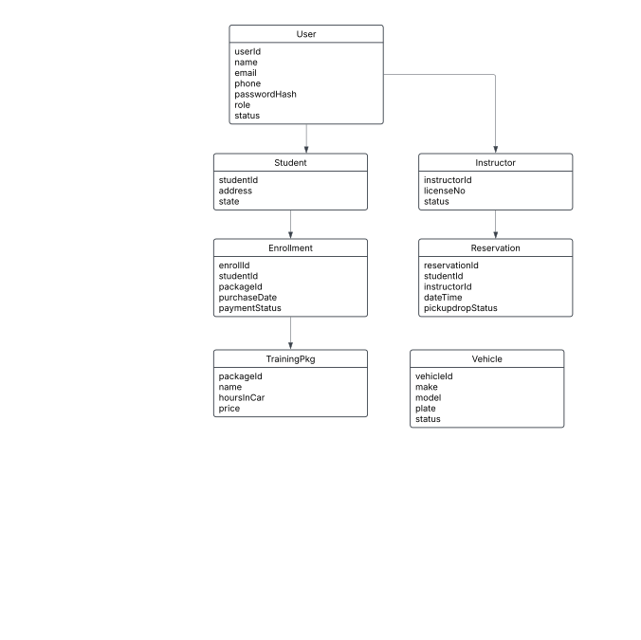

Technical Requirements
[Based on the diagrams you have created, describe the technical requirements of your system. These requirements should address the required hardware, software, tools, and infrastructure necessary for your system design.]

